 | 
 | Electric Vehicle Research Project |  |  | CUSTOMER GUIDE  March 2011
 | 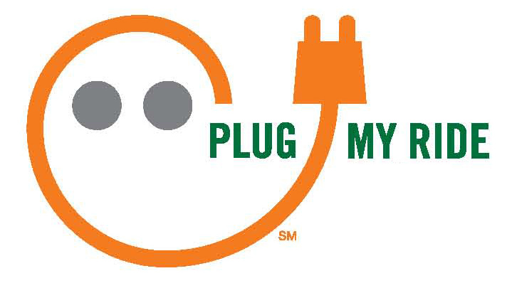

 | Table of Contents page  EV Research Project Overview 3  Customer Requirements 4  Equipment 5-6  Where to install your EVSE 7  Marketing support 8  At-A-Glance |  | Introduction  Northeast Utilities (NU) has been studying transportation electrification for several years and is actively involved in today’s emerging market for plug-in electric vehicles (EVs).  For this Electric Vehicle Research Project, we are collaborating with 25 municipalities and commercial/industrial customers of Connecticut Light & Power (CL&P).  This Customer Guide explains the details of the EV Research Project for participating organizations.  Thank you for your interest as we work toward a cleaner energy future for our region.
 | ▼ | ▼ | ▼ | ▼ | ▼ | ▼ | ▼
CUSTOMER  CL&P | Get started w/AE, call Clearing Desk | Letter of  Agreement  authorized | EVSE  shipped;  signage produced | Installation  completed | Joint  publicity | EVSE upkeep, user help | Data  sharing  thru 2013

 | EV Research Project Overview  CL&P will provide EV charging equipment at no cost to participating organizations that agree to the Research Project’s criteria.  Research Objective  Our goal is to share learning and hands-on experience by deploying EV charging infrastructure in various community and business settings.  Customer Selection Criteria  Selected participants are “early adopters” who have a strategic interest in EVs, and who are ready to take action now as the industry continues to evolve. Their personnel and facilities are well-suited for a controlled research project that broadly focuses on equipment, energy use and the behaviors associated with vehicle recharging.  Project Duration  This is a two-year collaborative research effort. |  | Components At-A-Glance
 |  |  | CL&P will provide at no cost:  - One Electric Vehicle Supply Equipment (EVSE) unit  - Choice of pedestal or wall-mounted  - Optional keypad (limited availability)  - Meter (for data usage)  - EVSE signage  - Joint marketing / publicity opportunities  - Online project resources  - Access to NU’s EV industry network | Customer agrees to:  - Install the EVSE in a mutually-agreeable location  - Provide ongoing / on-site support, such as maintenance, EVSE user help, electric usage included in monthly bill  - Display EVSE signage as part of “Plug My Ride” grassroots campaign  - Share data as requested, including informal feedback, periodic online surveys and meter usage
Why Conduct EV Research? At CL&P, we believe EV research is important for several reasons:
- Creates a hands-on learning lab for away-from-home EV charging infrastructure
- Outcomes may guide future EV-related policy decisions in the state
- Keeps Connecticut at the forefront as automakers allocate EVs and roll-out new models in selected areas
- Supports emerging EV market to help reduce the region’s carbon emissions and petroleum dependence

 | Discussion of Customer Requirements  Each participating organization will assume ownership of the EVSE received from CL&P, and serve as the site sponsor once the charging station is up and running for EV drivers’ use.  To ensure success, perhaps the most important decision is selecting and agreeing on the EVSE’s installed location. Customers should consult with their CL&P account executive and factor in the following criteria:  - Visibility to ensure that the EVSE is in a relatively open and attractive area  - Accessibility for a reasonable number of potential EV drivers (employees, customers or the general public)  - Availability of onsite support and / or a 24-hour phone number, should the EV driver require assistance  - Installation cost and maintenance considerations Refer to page 7 for specific suggestions |  | Letter of Agreement  The Letter of Agreement (LOA) is available from your CL&P account executive and from CL&P’s Clearing Desk.  Key points:  - Signed by CL&P and an authorized representative of the customer’s organization  - Insurance requirements (minimal property/liability coverage)  - CL&P provides the EVSE at no cost (with a meter and related equipment)  - Customer owns the EVSE  - Customer arranges for a licensed electrician to install the EVSE, including wiring, meter socket, permitting and other local requirements (standard procedure)  - Customer pays for the EVSE’s electricity as part of regular utility service  - Customer provides EV-related data / access as requested by CL&P during the Research Project  - Announcements or publicity regarding the customer’s participation in the Research Project require advance notice and authorization by both parties

 | Equipment Provided by CL&P  Electric Vehicle Supply Equipment (EVSE)  - For Level II recharging (240v)  - Clipper Creek model CS-40 (UL Listed)  - Same unit used at CL&P / NU facilities  - Level II recharging times for top 2011 models: |  |  | EVSE Choices for Participants:  - Wall-mounted or pedestal-mounted EVSE  - With optional keypad – subject to availability  - Provides access control to EVSE via a PIN code  - Monthly subscription fee waived by supplier for units in CL&P’s Research Project  - Supply is limited so first come, first served
   | Approx. | EV Type
  Chevy Volt | 4 hours | Extended range  (battery / gas engine
  Nissan Leaf | 7 hours | All-electric  (battery only)
 | 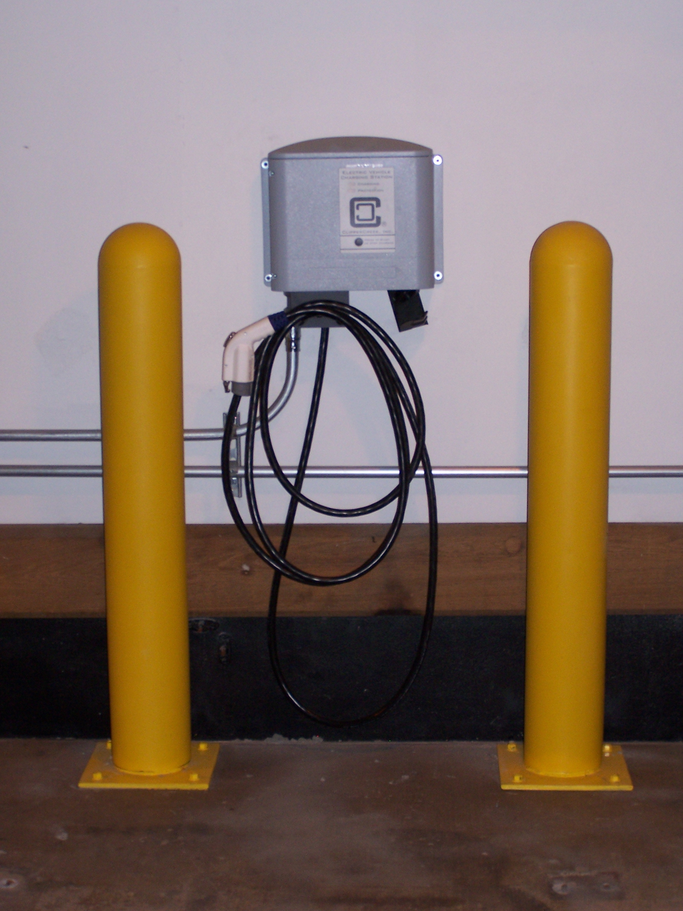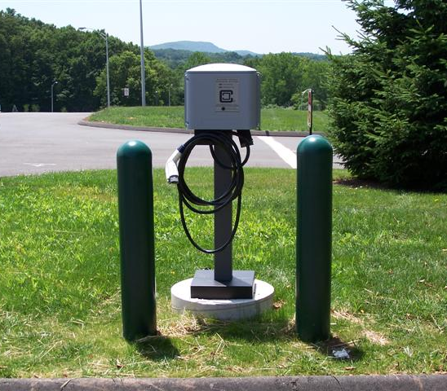 |  |  |  | 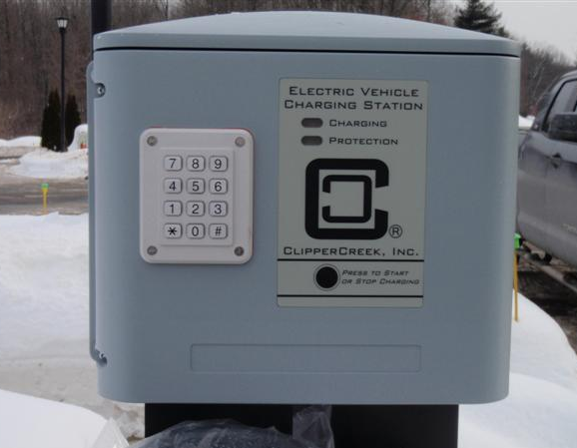
 | Wall-mounted unit Pedestal-mounted unit |  |  |  |  | Unit shown with optional keypad  for access control (supply is limited)

 | Equipment (continued)  J Connector  - Society of Automotive Engineers standard: SAE J1772  - Compatible with:  - Chevy Volt and Nissan Leaf  - Pre-production models such as Toyota Prius Plug-in  - BMW ActiveE (summer 2011 field test in Conn.)  - Not compatible with:  - Conversion EVs  - Pre-2011 Tesla Roadster  - A few other models |  | Normal Installation by Your Licensed Electrician  - Follow the required town permit process  - Circuit  - Single phase, 240v or 208v, 40 amp from your existing circuit panel  - Conform to National Electric Code and local requirements  - Meter socket  - Approved socket from Information & Requirements book (I&R)  - Some flexibility for location but cell phone reception is a must  - Preferable: With line to existing phone service
Meter Data
When the EVSE is used for vehicle charging, the meter will capture usage data and automatically transmit it to CL&P’s data management system for storage.

CL&P will provide aggregated usage results periodically during the Research Project. For retrieval of individual meter data, options are available through your CL&P account executive.

Opportunities for analysis include:
- kWh usage
- Length of each charging session
- Date / time of day
- # of sessions per day, week, month

 | Tips for Choosing the Right EVSE Location  - Against a wall or on unpaved ground is easiest  - Minimize hard surface (pavement, sidewalk)  - Situated between two parking spaces is ideal, so an EV can park in either one  - However, the EVSE charges only one car at a time  - Be mindful of where the cord will be when charging a car  - Shouldn’t stretch across a walkway or become a safety hazard  - Outdoors vs. indoors, controlled or uncontrolled access  - Factor in snow bank / snow plow areas, mowing, proximity to special equipment  - Decide whether to mark space(s) “EV PARKING ONLY” |  | When You’re Ready to Proceed  Once your EVSE location is determined and you’re ready to proceed, your next step is calling CL&P’s Clearing Desk at 1-888-544-4826. Hours are Monday through Friday, 8:00 a.m. to 4:30 p.m.  You will be asked to provide the following information:  - Specific location of the new EVSE, including the location of the sub-meter and cross street  - Existing Meter # and the physical location of the meter that supplies the EVSE circuit  - Choice of wall-mounting or pedestal-mounting  - Optional keypad if you require PIN-code access (limited supply is first come, first serve)  - Customer contact information  - Mailing address for Letter of Agreement (also available from your CL&P account executive)  - Contractor information (person doing your installation)  - Shipping address for delivery of EVSE unit  Refer to the Process Flow Diagram (accompanying this booklet) which maps the sequence of events, from initial phone call to completion of the EVSE installation.

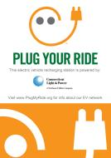  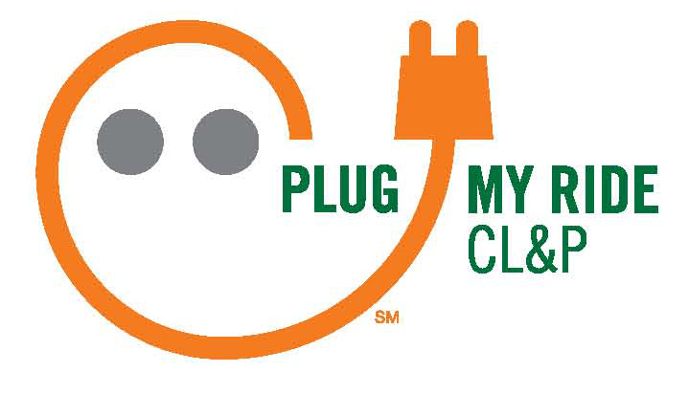 | “Plug My Ride” Grassroots Campaign  Northeast Utilities and CL&P developed “Plug My Ride” as an upbeat way to promote awareness of EVs and connect the region’s growing community of EV supporters.  ► Custom Logo for Local Use  Customers can have their names incorporated into the “Plug My Ride” graphic (shown at right) for use wherever and whenever you’d like – websites, newsletters, banners, stickers, etc. Electronic artwork will be coordinated through your CL&P account executive.  ► “Plug Your Ride” Sign for EVSE  Participants in the EV Research Project receive one sign for display near the EVSE provided by CL&P. Choose from a variety of styles with the option of adding your logo, if appropriate. CL&P’s authorized sign company will work with you or your designee for trouble-free, professional results. See accompanying sheet for instructions and samples.  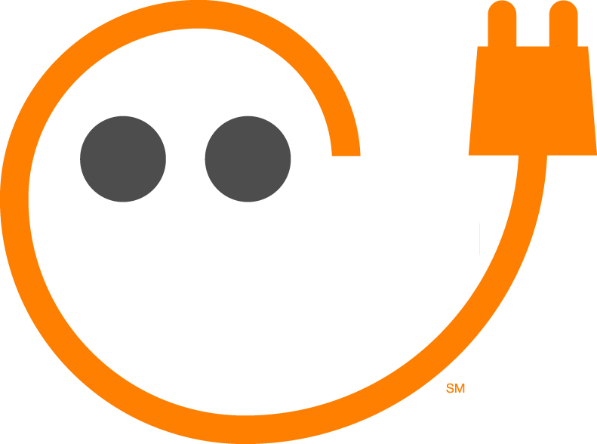  ► Added Attractions  Meet Cordon! He’s available as  a giant stencil so you can spray-  paint him in bright orange onto the  pavement of your EV parking space. |  | Your NAME
Joint Publicity / Promotions

CL&P is ready to work with you on news releases, photo opportunities, VIP ribbon-cuttings, website content, social media and other outreach to your internal and external audiences. (Advance approvals required.)

Join our Online Workroom:
EVresource.groupsite.com

Once you receive our email link, it takes just seconds to register for this password-protected online resource where you can:
- Interact with other EV Research Project participants
- Post questions online
- View presentations by NU’s Watson Collins and others
- Download EV charging equipment guides
- Check out the photo gallery
- Network with NU’s EV contacts, including automakers

See accompanying sheet for details.

