Electric Vehicle Research Project | CUSTOMER  GUIDE  March 2011
Ordering signage for your EVSE
from CL&P

CL&P is providing one sign for your installed EVSE. As a new twist to the campaign theme, this “Plug Your Ride” sign helps EV drivers locate your charging station.  Use our turn-key process for professional results.  STEP 1 Tell your CL&P account executive:  - Who is the point of contact for CL&P’s authorized sign company  - What are your preferences based on the styles shown  [ LETTER OF AGREEMENT IS SIGNED BEFORE PROCEEDING ]  STEP 2: Sign company representative calls your contact person to arrange a site visit  STEP 3: Sign company visits EVSE location and recommends size, materials, installation method and optional logo for approval  - Optional: Customer provides logo (file format: eps or ai). If necessary, a design proof will be submitted for approval  STEP 4: Once specifics are approved, sign is produced  - Delivery occurs after EVSE installation  STEP 5: Sign company calls your contact person to schedule installation  STEP 6: Sign company completes installation and emails a photo  AVAILABLE UPON REQUEST from your CL&P account executive:  ► Artwork in electronic format to produce additional signs  ► A giant “Cordon” stencil to spray-paint on pavement or walls | Hi, my name is  Cordon ► | 
 | Hi, my name is  Cordon ► | Sign Specifications ▲  Dimensions: Approx. 12” x 17”  Mounting: Standard sign pole  Material: Metal  Optional: Two-sided  See more examples on back.

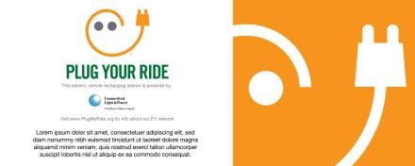
Sign Specifications ►

Dimensions: Approx. 30” x 12”
Mounting: Affixed to wall
Material: Metal
Optional: Custom sized with
wall-mounted EVSE

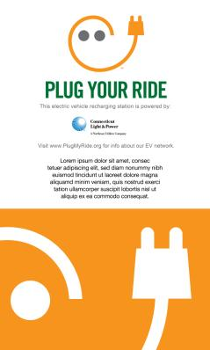
Dimensions: Approx. 3 ft. x 5 ft.
Mounting: Double channel poles in
cement footings
Materials: Wood, Sintra PVC
Optional: Two-sided
◄ Sign Specifications
Best for Unpaved Ground
Optional:
Customer logo
next to CL&P logo

