Electric Vehicle Research Project | CUSTOMER  GUIDE  March 2011
Using the project’s online workroom
at EVresource.groupsite.com

- Watch for an email invitation from “NU EV Research Resource” and click on the link to join  - It’s simple to register and log-in: your USER NAME is your email address, and you choose your own secure PASSWORD  - You’ll find lots of interesting info: FAQs from fellow participants in the EV Research Project, answers from our team, a photo gallery of EVSE installations, archived presentations, and much more  - Click on the SHARE menu and go to the FILE CABINET: a convenient, one-stop library of resources, including these Clipper Creek equipment guides |  |  |  | 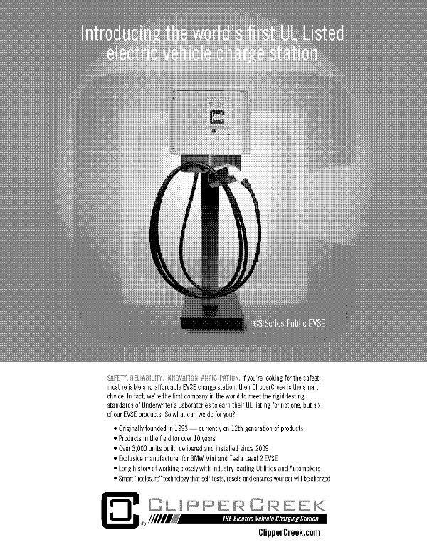
 |  |  |  | Conveniently download Clipper Creek equipment information and more
All Research Project participants have password-protected access to our Groupsite.  Post your own questions or learn from others, share tips and photos, participate in online surveys. | 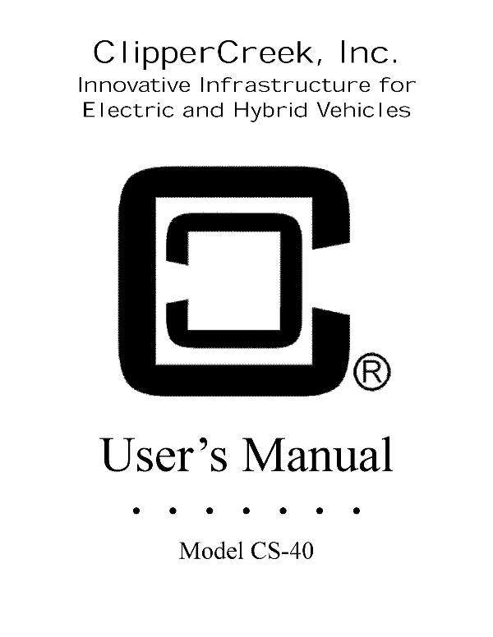 |  |  | 